* Purpose : Classwork
* Date : 23/12/2025
* Author : Vikas Srivastava
* ID : 55984
* Batch ID : 25SUB4505
--------------------------------------------------------------------------------------------------------------------------
- Code : Write a program to accept a person’s name and age from the user and determine their education level using an if–else if ladder based on predefined age categories.
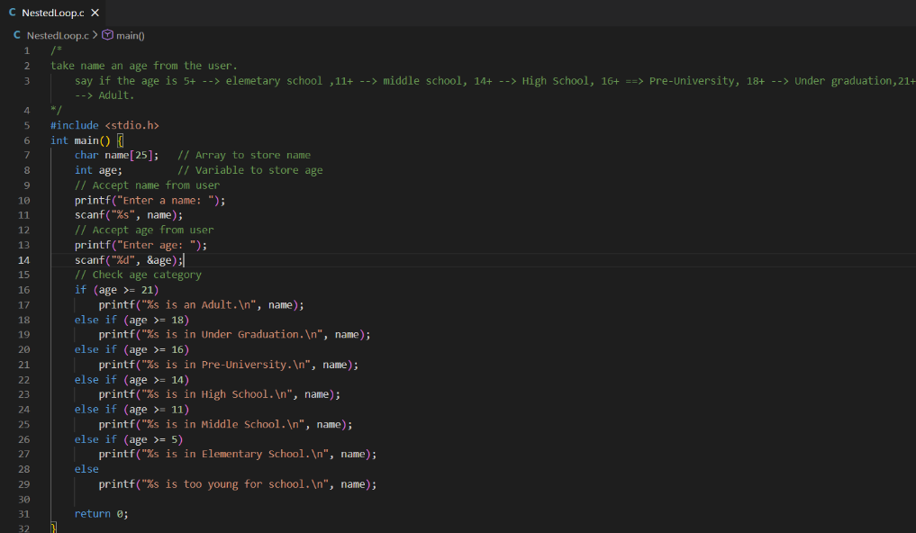
Output :
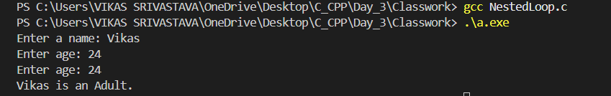
- Code : Write a program to accept an integer from the user and count the number of digits in it using a while loop, handling 0 as a special case.
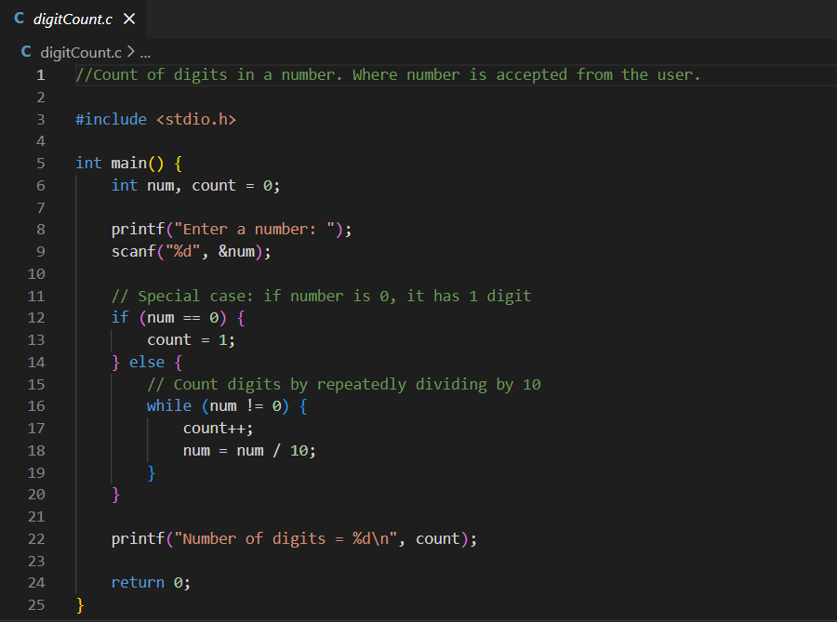
Output :
: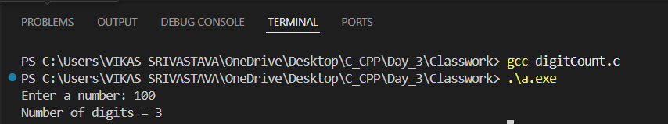
- Code : Write a program to generate and display the Fibonacci series up to a user-specified number of terms using a for loop, where each term is the sum of the previous two numbers.
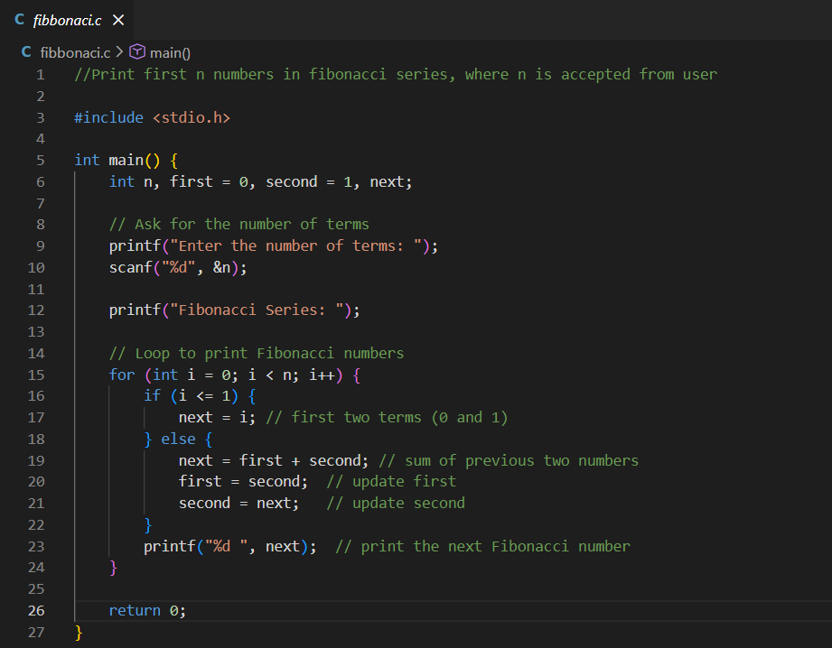
Output :
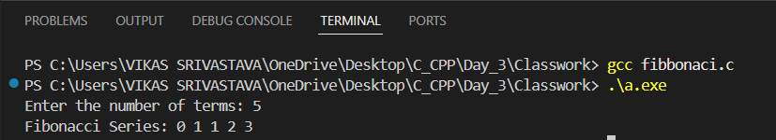
- Code : Write a program to accept three integers from the user and determine the largest number among them using if–else if–else conditional statements.
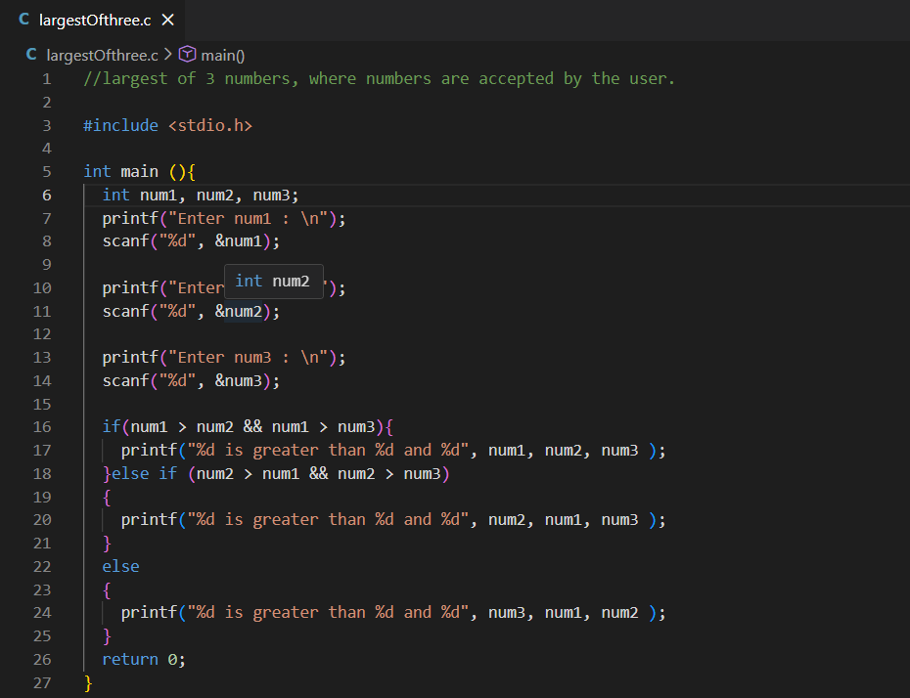

Output :
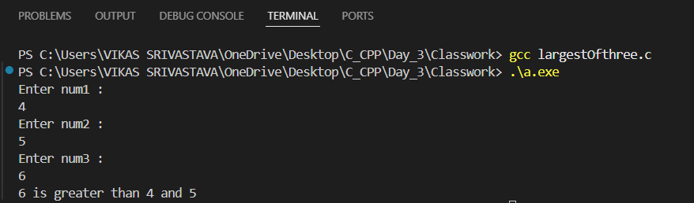
- Code : Write a program to check whether a given year is a leap year using conditional statements and logical operators based on standard leap year rules.
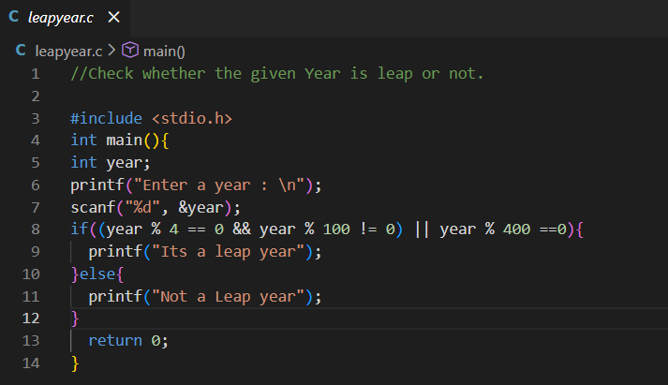
Output :
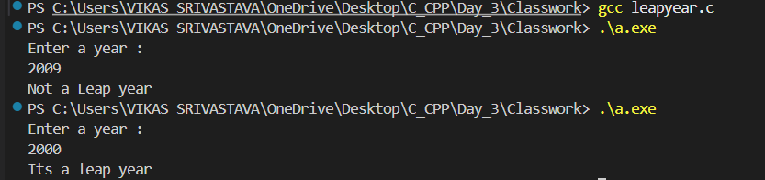
- Code : Write a program to store multiple strings in an array and determine the longest string by comparing their lengths using the strlen() function.
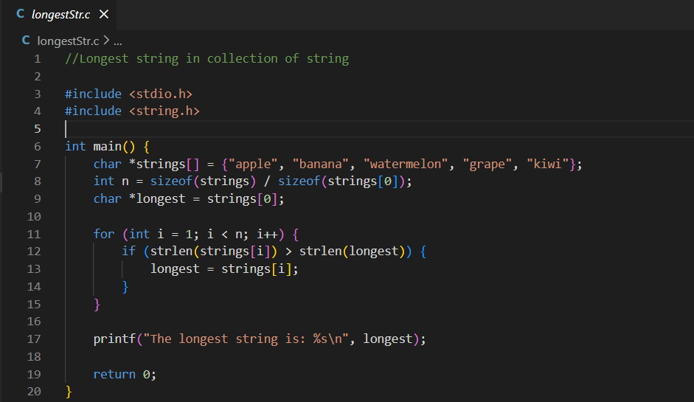
Output :
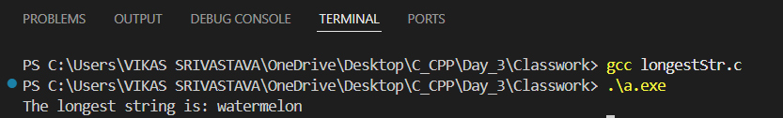
- Code : Write a program to demonstrate pointer basics in C by showing the relationship between a variable, its address, a pointer storing that address, and the use of dereferencing (*) and address-of (&) operators to access values and memory locations.
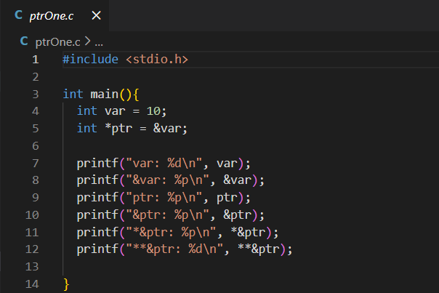
Output :
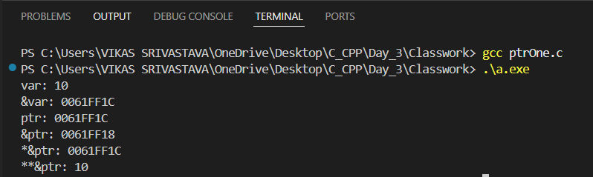
- Code : Write a program to accept an integer from the user and reverse the number using a while loop by extracting and repositioning digits one by one.
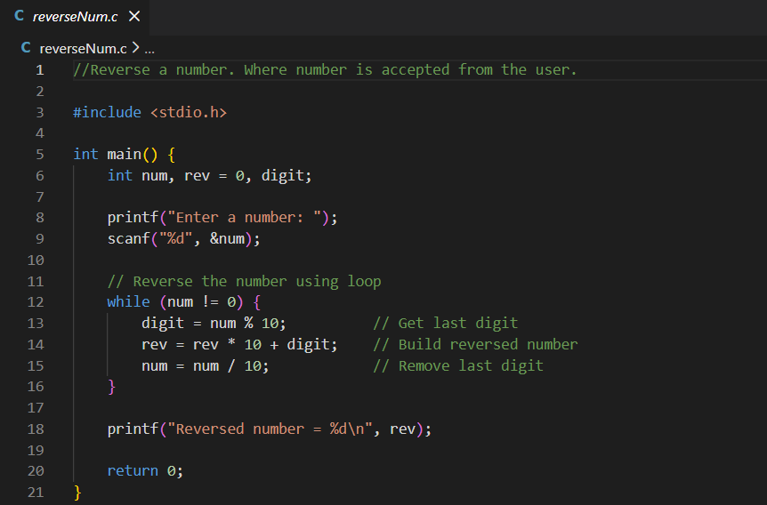
Output :
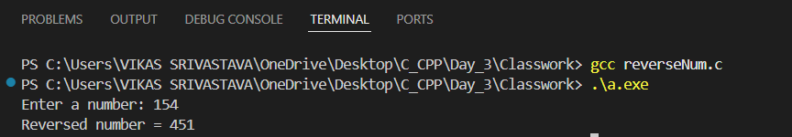

- Code : Write a program to calculate Simple Interest by accepting the principal amount, rate of interest, and time from the user and applying the standard formula SI=(P×R×T)/100SI = (P \times R \times T) / 100SI=(P×R×T)/100.
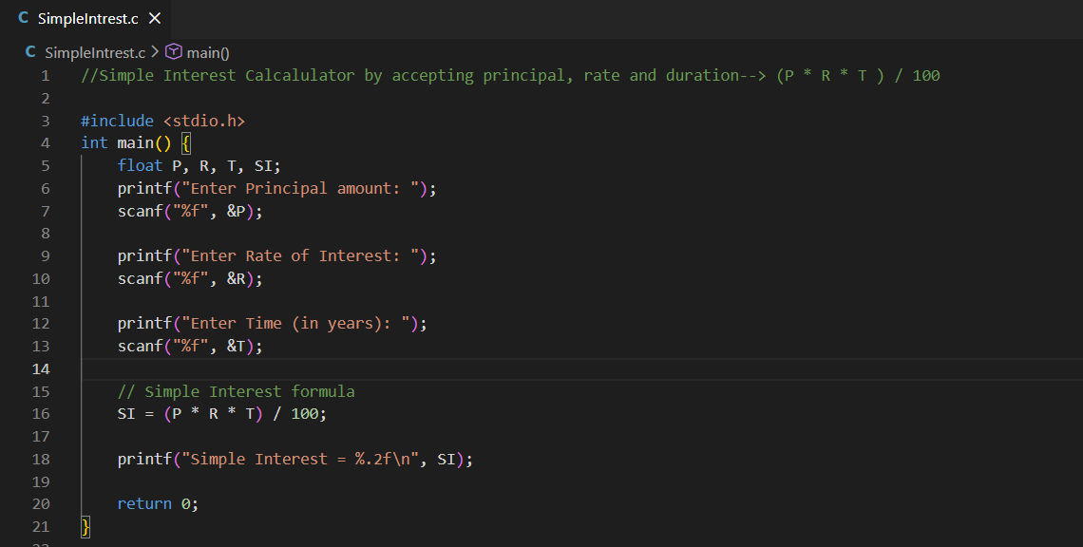
Output :
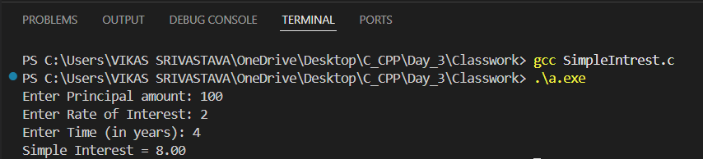
- Code : Write a program to demonstrate how a single string and multiple strings can be stored using a character array and a two-dimensional character array, and then displayed using a loop.
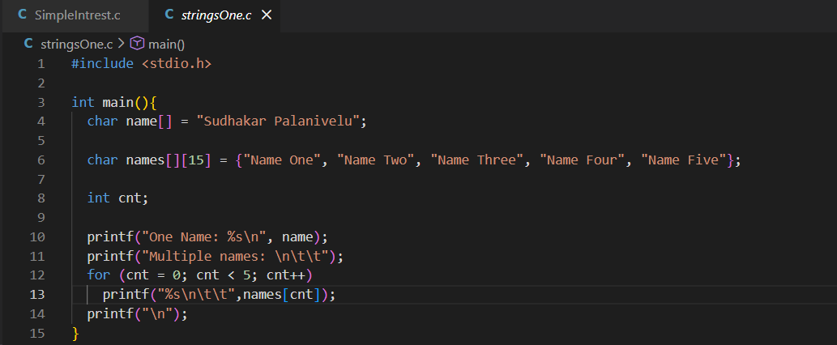
Output :
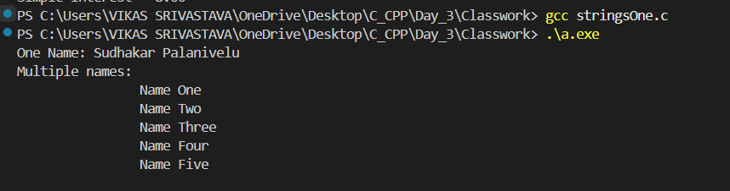

- Code : Write a program to accept a number n from the user and calculate the sum of the first n natural numbers using a for loop.
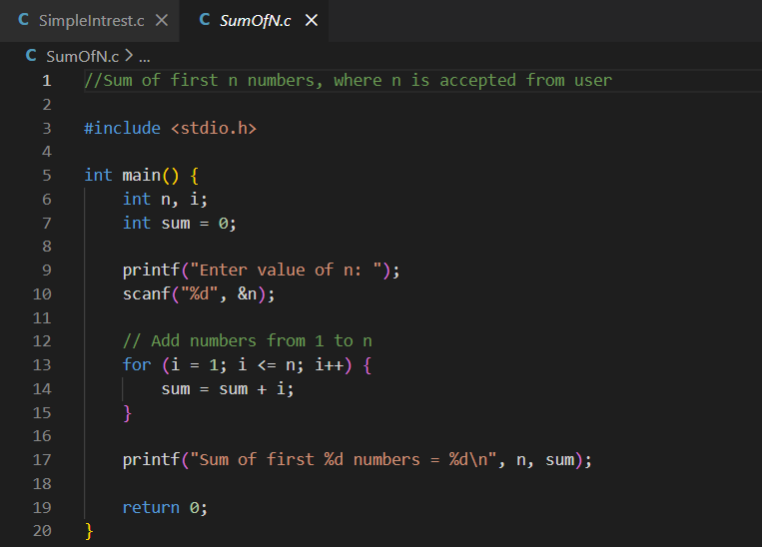
Output :
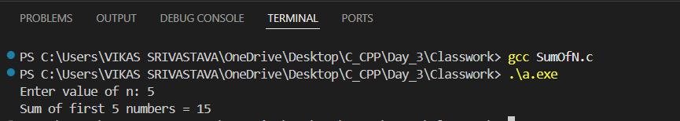
- Code : Write a program to accept two integers from the user, calculate their sum, and display the result on the screen.
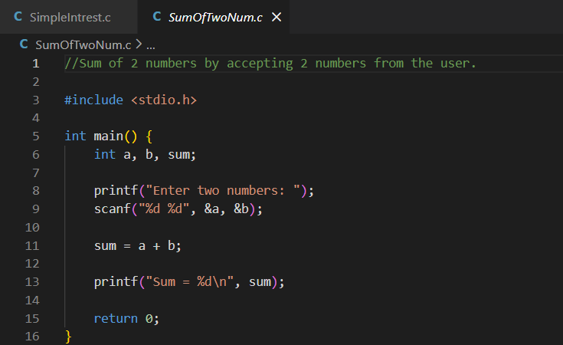
Output :
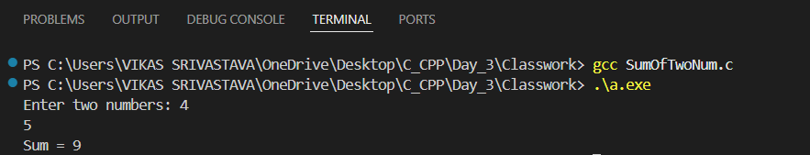

- Code : Write a program to accept two integers from the user, perform addition, and display the sum of the two numbers.
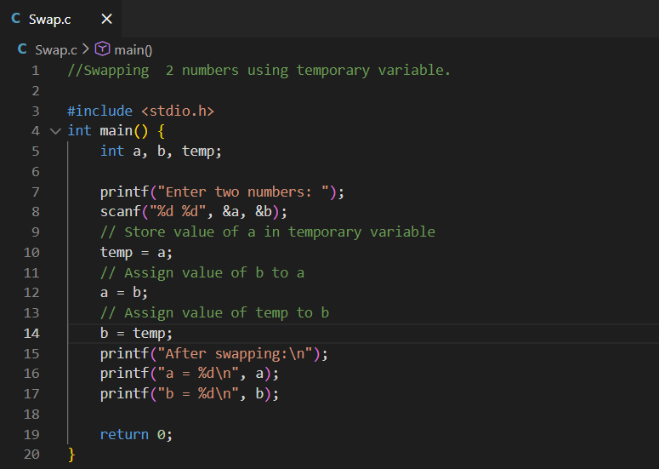
Output :
